CBA - Unit 2 Word Processing
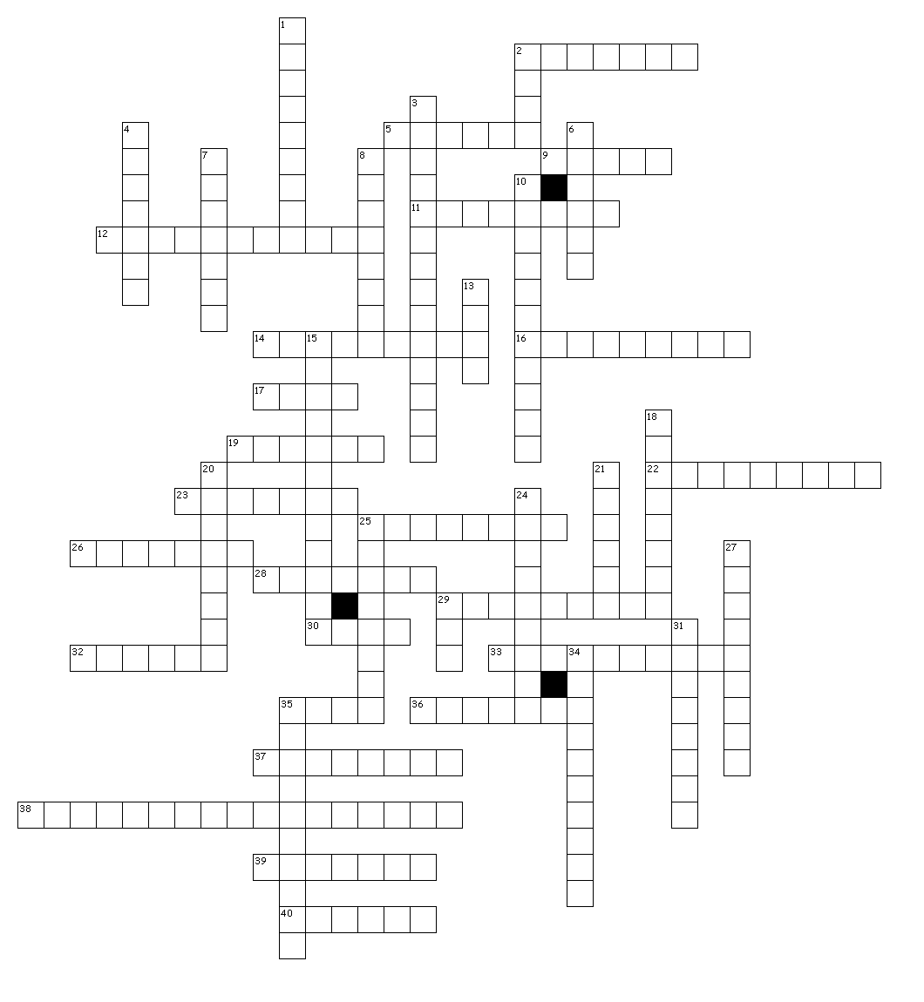

Across
2. brochures, etc.
5. in word processing, to utilize features that enhance the appearance and overall layout of text, graphics, tables within a document
9. a set of data arranged in a grid of rows and columns
11. one; also known as a Soft Page Break
12. the amount of space between lines of text
14. a feature that allows a user to select text or a graphic, duplicate it and place it in another location within a document
16. the measurement, or size of a font (text); each point is approximately 1/72 of an inch
17. to make changes by adding, deleting, or modifying text, graphics, or other items in a document
19. text appearing at the bottom of each page, separate from the main body of a text
22. sort order arranging text or numbers from A to Z, from smallest to largest, or from earliest to latest
23. text created as a graphic image
25. also called a soft return; a feature that automatically moves text to the next line when the previous line is full without the user pressing
26. a feature in a word processing application that allows the user to create outlines or itemized lists with either icons or numbers
28. a feature that includes pre-made illustrations, drawings, pictures, and other graphic that can be inserted into a document
29. a feature that allows the user to view synonyms and antonyms, and automatically replace words for enhanced writing
30. new text, symbols or formatting
32. to move text horizontally away from the left or right margin, setting it apart from surrounding text
33. a break in a line or a paragraph that is forced by the user when the return key is pressed, creating a new paragraph
35. to arrange a list alphabetically (text) or numerically (numbers), in ascending or descending order
36. lines around the edge(s) of text, a page, a cell, or a table
37. a feature that includes pre-made documents that allow the user to fill-in-the blanks to create new documents
38. through the use of a personal computer, combining text and graphics to produce a high-quality documents, such as newsletters,
39. the background color of a cell, table, or page
40. one of two or more vertical sections of printed material on a page; usually separated by margins

Down
1. a feature that automatically generates a new page, allowing text to flow to the new page when space runs out on the
2. the size, style, and design of text
3. the use of software application to create, edit, format, print and save text-based documents, such as letters, reports, and memos
4. the white space surrounding the content of a page at the top, bottom, left and right sides, defining where a line of text begins and ends
6. a page break the end user forces into a document, creating a new page at a specific location; also known as a Hard Page Break
7. a formatting feature that allows the user to control where a line of text will be entered and how the text will be aligned; so that when the tab is pressed, the insertion point will move to that location
8. a feature that allows a user to select text using a mouse or pointing device, and quickly move (drag) it to a different location
10. a feature that scans a document, searches for occurrences of specific text, symbols or formatting, and allows a user to replace it
13. a feature that allows the user to view the current page of a document onscreen in a different ways
15. a feature that allows the user to view a document onscreen and make necessary formatting changes prior to printing it
18. drawings, pictures, or other illustrations inserted in a document to either explain data or enhance the appearance of text on a page
20. Orientation a page layout in which documents are printed across the width of a page, making the page taller than it is wide
21. text appearing at the top of each page, separate from the main body of text
24. orientation a page layout in which documents are printed across the length of a page, making the page wider than it is tall
25. a feature that allows text to be included with pictures, shapes, or tables without covering or hiding under the image, giving the user control over how the text is position
27. how the edges of a line, paragraph, object, or table are positioned horizontally and vertically between the margins or on a page
29. enter key
31. a feature that allows a user to select text or a graphic, remove it from its current location and place it in another location within a document
34. sort order arranging text or numbers from Z to A, largest to smallest, or latest to earliest
35. a feature used to automatically locate and correct spelling errors

