Understanding Resolution & Digital Cameras
- Resolution: Understanding digital cameras requires that we know how resolution works.
    - Resolution is determined by how many ___________________ (picture elements) or ____________ (dots per inch) are available.
    - An image is a ___________ of small squares or circles filled in with color. The _____________ squares or circles—the _____________________ the image.
- Measuring Resolution
    - Resolution is measured by the number of ________________ pixels times the number of _______________ pixels. Example: 3072 x 2304
- Megapixels: The _______________________ of a picture is measured by its resolution—how many pixels it has; the current measurement is _________________________.
    - A megapixel is a grid containing _______________________ pixels (one million squares of color)—technically, that is an image with a resolution of 1024 x 1024 pixels.
- Resolution: There are three different resolutions to consider: the image, monitor and printer
    - Image resolution: The image’s resolution is measured in _______________. Most cameras allow you to ____________ the resolution before you take the picture. The __________________ the resolution—the clearer the image—the ___________________ the file size.
    - Monitor resolution: Monitor resolution is measured in horizontal and vertical ___________________.
Ex: __________ ; If an image is taken at _________________, but your monitor can only display _______________—that’s as good as it gets!
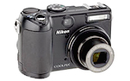
    - Printer resolution: Printer resolution is measured in dpi—_____________________________ ; The quality of the printed image is going to be determined by both the resolution of the __________________ AND the resolution of the _____________________________.
- Point and Shoot Cameras
    - Most digital cameras designed for the __________________ (vs. professional) are point and shoot cameras; they fall into three categories: subcompact, compact and super zoom
    - The camera lenses are _________________ (not ________________)
    - Basic features typically include auto ________________, auto _________________ and built-in ______
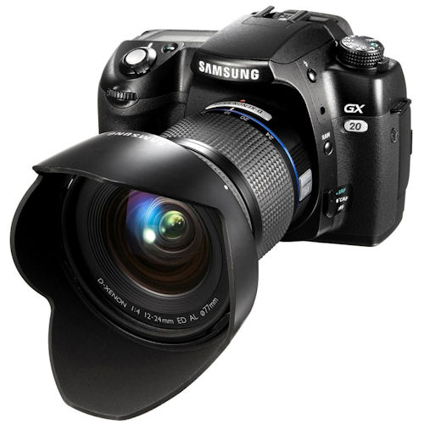
    - Not appropriate for _______________________ photography because of ____________ time
- SLR Cameras (_____________________________________________)
    - With an SLR camera, you see exactly what the _____________ sees
    - You can _____________________ the lens on a digital SLR
    - You choose the lens based on the _____________________ of photography; example: portrait photography vs. sporting events vs. landscape photography, etc.
    - SLRs produce _______________________________________ photos than point and shoot cameras
    - An SLR has a _____________________________ lag time, and is ideal for ________________ photography
- Other points to consider: When purchasing a camera, you should also research the following specifications: storage capacity, transferring images, power source, LCD vs. optical view finder, zoom, image stabilization, the Exposure Triangle—ISO, shutter speed and aperture
    - Storage devices
      - Memory cards: Give two examples of memory cards
      - What storage capacity is currently available?
    - Internal memory (RAM): The number of pictures you can take before sending them to your computer is determined by two things: _____________________________________________________________
- Transferring images
    - List three methods that images can be transferred from your camera to your computer
- Power source
    - Regular Batteries
    - Rechargeable batteries: ______________________________________________________________
    - AC
- LCD vs Viewfinder
LCD |  | Viewfinder
PROS | CONS | PROS | CONS
- Zoom
    - Optical zoom actually _____________________________ the image—measured in _________________
    - example: 8X—increases an image 8 times
    - Digital zoom takes a portion of an image and enlarges it _______________________________; the image loses resolution when the camera enlarges it; also measured in X
    - Macro allows you to take _____________________________ pictures of objects that are small and enlarge them so they appear larger.
- Image Stabilization
    - A feature in digital cameras that ____________________ the _____________________ that can occur when taking a picture.
    - Vibrations commonly occur when shooting at __________________________ speeds, with longer __________________ or with ____________________ zoom.
    - Also called _______________________
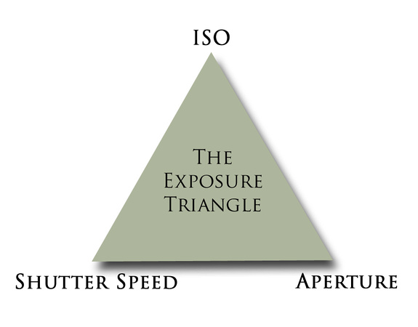
- The Exposure Triangle
    - Exposure is the total amount of ___________________ you let into your camera.
      - Too much light results in an ______________________________ image where there are areas of bright white or “________________________.” These areas contain no ____________________________________.
      - Too little light results in an _____________________________ image which leaves parts of your image too ________________ to make out details.
    - The three components to exposure are ________________________________________________________
      - ISO—the measurement of how __________________________________ the image sensor in the camera is to _____________________.
        - Measured in numbers _______________________________________, etc.
        - Use a __________________ number when smooth crisp images are needed and you have plenty of ____________________.
        - _______________________ numbers are used when light is ____________________, you do not want to use a ______________________, or the subject is moving; may result in _________________________ images
      - Shutter Speed—the amount of ____________________ the shutter is ____________—which determines how much light is _______________ in the recording process
- Measured in ____________________: super fast 1/2000 second to 30 seconds
- The ________________________ the speed, the _______________________ light can enter the camera. Appropriate for shooting pictures in _____________________________ situations; also great for ___________________ action and movement
      - Aperture—the camera feature that ____________________________ the amount of light that passes through the lens by controlling the size of the _________________________ in the lens
- Described as the ________________ (a _____________________ is a change in setting)
- The ______________________ the number the ____________________the lens will open
