Typography (Subway Art) Poster Project
Research online the many different styles of subway art posters. (Tip: Use Pinterest and Google Images for your research.)
Using InDesign, create a 24” W x 36” H document size palette.
Use a variety of fonts and styles to create a creative and well-organized layout of typography. (Download fonts if necessary.)
Apply a variety of CMYK complementary colors to your words. (Use at least one Pantone swatch palette color to learn about Pantone colors.)
Print your poster on the large poster printer.
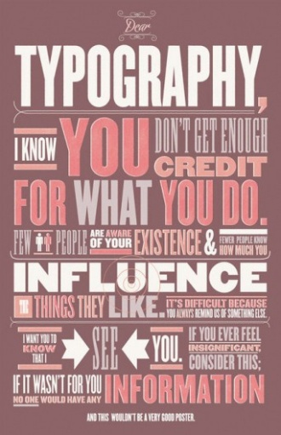
Grading Rubric:
10 pts – 24” x 36” in Size _____
20 pts - Variety of Fonts _____
20 pts - Variety of Colors _____
20 pts- Justified Alignment ____
10 pts – No trapped space ____
20 pts - Creativity/Design _____
Total Points Earned __________

