Paper – Lesson Plan
Objectives: --To identify different types of paper
--To demonstrate the basic paper folds
--To demonstrate the ability to trim, cut and bind paper
ACTIVITY 1: IDENTIFY TYPES OF PAPER
Materials: Manila folders
Samples of different types of paper, i.e. card stock, linen, parchment, bond, cotton, etc.
Tape or glue sticks
Pen/pencil

Procedure:
- Cut samples of paper into small pieces, about 1.5 x 1.5 or 1x3
- Have student tape/glue the samples inside manila folder and then label according to the sample’s description.

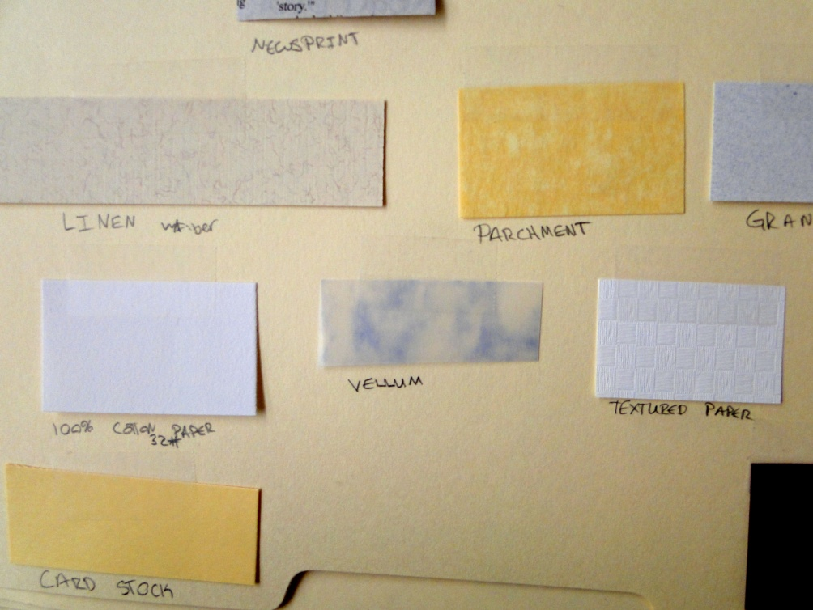

ACTIVITY 2: DEMONSTRATE PAPER FOLDS

Materials: Letter size paper, cut into fourths
Pencil/pen
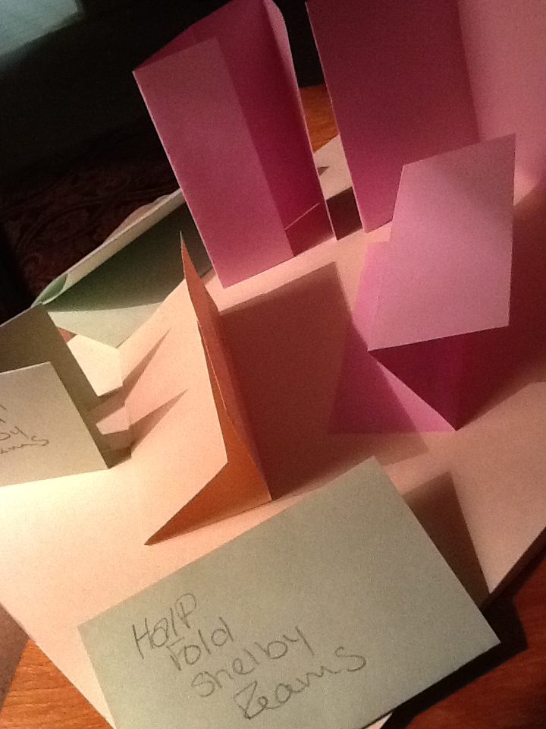
Procedure:
- Give each student eight pieces of paper
- Have the students demonstrate the following folds. Label each piece of paper with the type of fold and the student’s name.
z-fold, half fold, French fold, gate fold, tri-fold, roll fold, closed gate fold, double parallel fold

PAPER ACTIVITY: CUTTING AND BINDING
- Use the paper cutter and two pieces of letter-size paper to do the following:
  - Cut one piece of paper into four equal parts, with no pieces leftover.
  - Trim the second sheet of paper to 5”x7”.
- Use the long-arm stapler and two sheets of letter-size paper. Staple the sheets together like a booklet. Fold correctly.
- Use the paper trimmer and one piece of paper to do the following:
  - Create a scored line approximately one inch from the end of the paper
  - Create a perforated line approximately one inch from the opposite end of the paper
  - Trim all the corners
- Use the binder, one binding strip and one piece of paper. Punch the paper and attach the binding strip.
- Put your name on each piece of paper and paperclip together to turn in.

