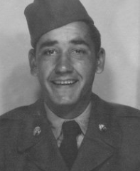
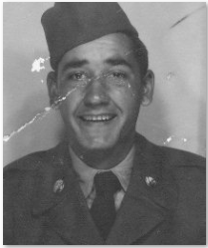
Objective: Use photo editing tools to repair damaged photo.
Procedure:
- Open damaged photo from Moodle
- Save it to your computer
- Load damaged photo in Photoshop
  - File > Open
- Change Resolution/Size
  - Image > Image Size > 300 pixels per inch
- Use editing tools to repair damage

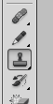
Clone Stamp Tool

- Select tool
- Adjust tool diameter
- Choose Target Area
- ALT – Click to tell tool what area to duplicate
- Click to cover damage
** As the curser is moved, so does the sampled target area.
You will need to re-sample as necessary

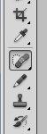
Spot Healing Brush

- Select tool
- Adjust tool diameter
- Center tool over area to be repaired
- Click
- Choose next area to repair

Select & Fill

- Use your preferred selection tool to select an area to be repaired
- Right-click inside selected area
- Click “FILL”
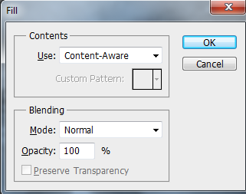
- Make sure FILL menu chooses Content-Aware
- Click OK

