DC IV: Unit 2 - Video Pre-Production/Production
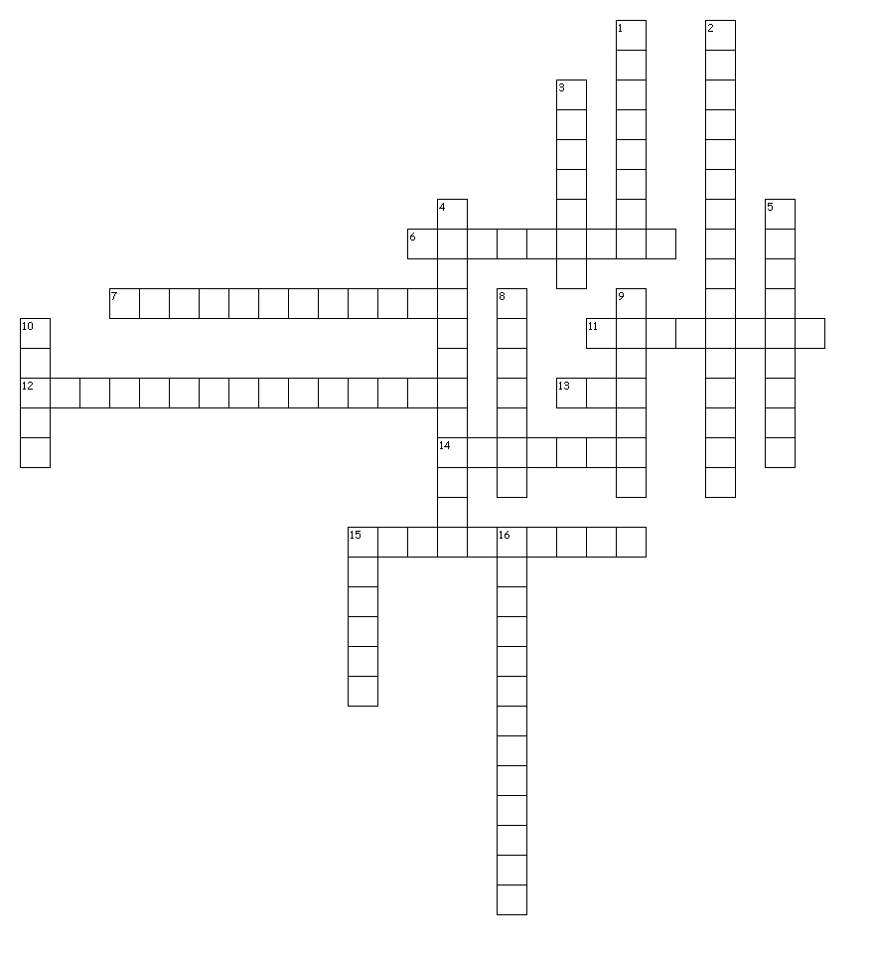
Across
6. a camera angle that shows the subject from above; camera is angled down towards the subject; not as extreme as bird's eye view
7. camera setting that adjusts for lighting in order make white objects appear white in photos
11. a camera angle that shows the subject from below; camera is angled up towards the subject
12. a camera angle that looks at the talking subject from the listener's perspective, literally over the shoulder.
13. a scene change in a movie; a quick move from one scene to another
14. a camera movement that scans a scene horizontally
15. a series of sketches that are used as a planning tool to visually show how the action of a story unfolds
Down
1. a camera angle which shows the subject as we would expect to see them in real life
2. usually the first shot of a scene, designed to show the audience where the action is taking place
3. altering the lens making a subject appear closer or further away.
4. person recording with a video camera
5. the ability of a camera to compensate in cases where a subject with a large amount of background light would otherwise be obscured.
8. a camera movement that scans a scene vertically
9. raw, unedited material as it had been originally recorded
10. footage video that is not custom shot for use in a specific film (archive footage)
15. a planning tool that includes the "spoken" text of a video production
16. a scene shot from directly above the action

