DCIII Unit 4: Animation
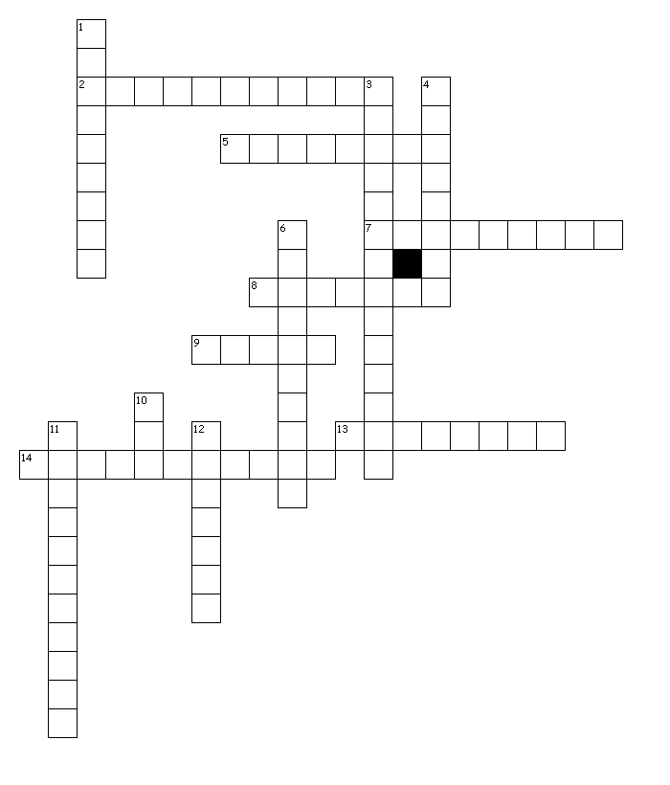
Across
2. a single graphic file that contains a series of images which are displayed sequentially to give the illusion of movement or change over time
5. a frame in an animated sequence of frames which was drawn or otherwise constructed directly by the user rather than generated automatically, e.g. by tweening
7. the simulation of movement created by displaying a series of pictures or frames
8. playing a sequence of frames over and over
9. an individual picture in a sequence of images
13. a special-effects process in which persons or objects seem to change shape, form, etc.
14. the creation of moving pictures in a three-dimensional environment; Objects can be rotated and moved like real objects

Down
1. (fps) the number of frames per second at which an animation or video is intended to be viewed
3. a computer animation technique that creates movement one frame at a time; the illusion of movement is created by displaying objects in slightly different poses or positions, one frame after another in rapid succession
4. an animation technique that, based on starting and ending shapes, creates the necessary "in-between" frames
6. animation where a model is moved incrementally and photographed one frame at a time
10. the application of the field of computer graphics (specifically 3D) to special effects
11. the creation of moving pictures in a two-dimensional environment, such as computerized animation software
12. a special-effects process in which an object is bent or twisted out of shape

