DCIII Unit 3: Audio/Sound
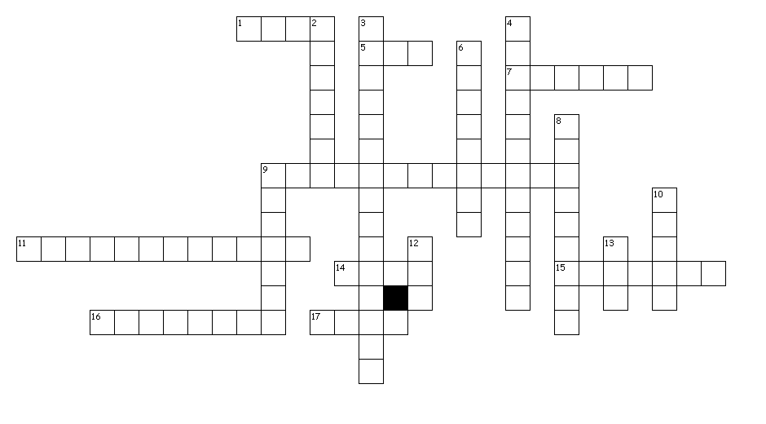
Across
1. a directional microphone that is mounted on a boom arm and positioned just out of camera
5. mpeg 3; a compressed audio file format that is the current standard for exchanging audio files over the Internet; 1/10 the size of a wave file
7. audio mixing is the process by which sounds are combined into one or more channels
9. microphone that picks up sound from two opposite directions
11. a distinctive piece created by an author or artist
14. musical instrument digital interface; format for recording music from synthesizers and other electronic instruments
15. the process of digitally extracting audio from CDs to your hard drive
16. a frame in a timeline where a change will occur; used in audio, video and animation production
17. an audio signal that is mixed together and routed through a single audio channel

Down
2. a microphone that is attached to a stand or boom
3. microphone that captures equally from all directions
4. the number of samples taken per second when sound is recorded; 1Hz-1 sample per second; currently measured in kilohertz; 44.1 is CD quality, 22.1 is radio quality
6. a small microphone designed to pick up speech from a single person, typically attached to the subject's clothing with a specialized clip
8. one thousand hertz; measures the sampling rate of an audio file
9. the number of bits per second processed when sampling sound (bps).
10. audible content in media production and publishing
12. audio interchange format; an uncompressed audio file format used by Macs
13. mpeg 4; a compressed file format that can be used for audio or video; appropriate for streaming

