DCIII Unit 2: Web Design
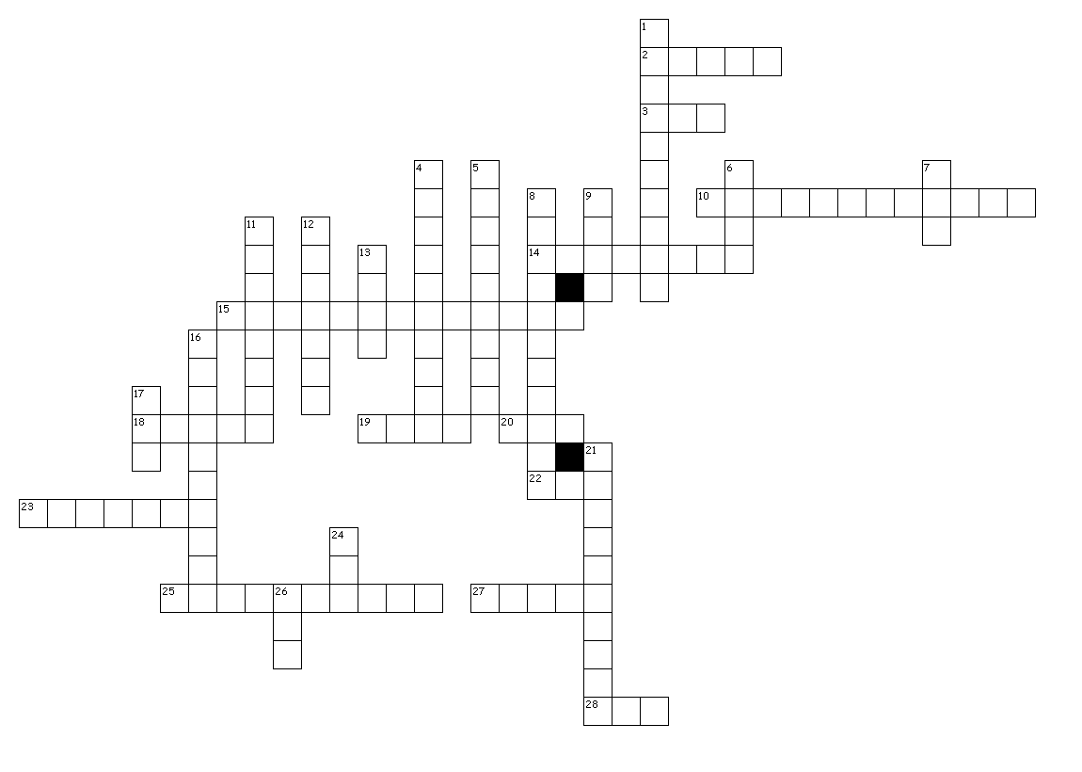
Across
2. a navigation button that changes when the mouse is positioned over it
3. top-level domain dedicated to delivering the internet to the mobile phone
10. map the organizational structure of a website
14. a set of predesigned formats for text and graphics on which new pages and webs can be based. After a page or web is created using a template, you can customize the page or web
15. 216 colors that appear consistently across web browsers and across computer platforms
18. map a region on a web page that contains one or more hot spots
19. map a list of the pages in a website; also referred to as a site index
20. top-level domain reserved for the business community
22. top-level domain reserved for the education community, typically higher education
23. one of a set of software modules that integrate into web browsers to offer a range of interactive and multimedia capabilities
25. providing space on Internet servers for the storage of World Wide Web sites which can be accessed by others through the network. This service is usually offered by ISPs or web hosting specialists
27. an area of a web page that allows the viewer to enter data and information to be sent back to the web server
28. top-level domain reserved for the government community
Down
1. miniature representations of a picture
4. language used to add special effects to a website
5. connection from one page to another or from one site to another
6. banner a section of a web page containing a graphic element and text, such as the page title, that is displayed at the top of the page
7. unrestricted top-level domain typically used by the commercial community
8. descriptive text that can be set to appear in place of an image
9. the predominant language used to create web pages
11. the top level or entry page of a website
12. an invisible region on an image that contains a hyperlink
13. unrestricted top-level domain
16. the part of an Internet URL (Universal Resource Locator) selected and registered by an individual, business or organization to represent their web presence. It consists of at least two parts that are separated by "dots." The last part or suffix indicates the type of site (top level domain) such as ".edu" for schools, ".gov" for government, and ".com" for commercial business
17. top-level domain reserved for the United States Department of Defense and its subsidiary or affiliated organizations
21. sending or uploading web pages to a server where they are made available on the Word Wide Web
24. unrestricted top-level domain
26. unrestricted top-level domain typically used by non-profit organizations or organizations of a non-commercial character

