Digital Communications II - Unit 4
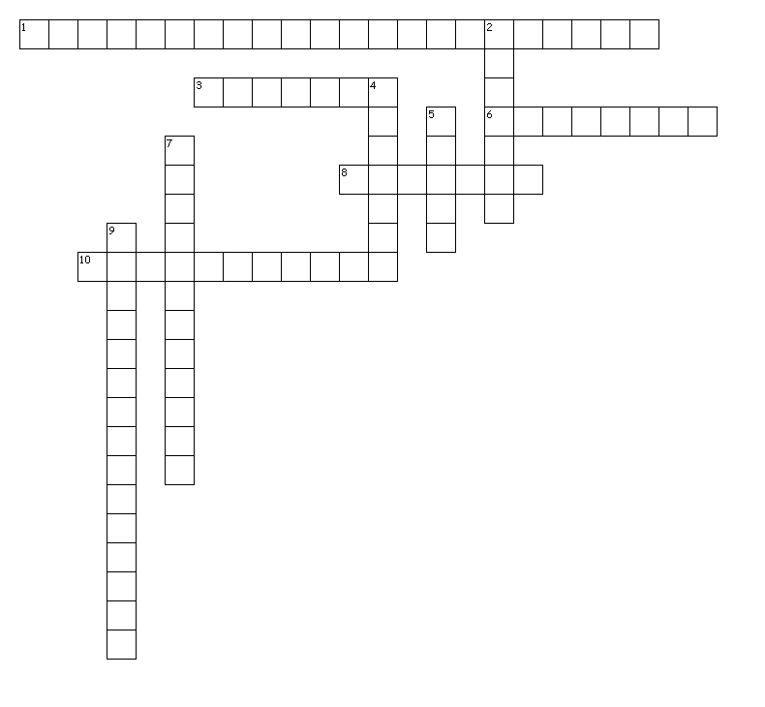

Word Bank
Columns
Footers
Headers
Index
Master pages
Portable Document Format
Printers marks
Spreads
Table of Contents
Template

Across
1. an extension for Adobe Acrobat Reader files
3. one of two or more vertical sections of typed lines lying side by side on a page and separated by a rule or a blank space
6. a publication that can be used as a "model" for the creation of new documents
8. identifying text that appears at the top of pages in a publication
10. pages that contain reoccurring items such as page numbers as well as other design elements

Down
2. repetitive text that appears at the bottom of the pages in a publication
4. facing pages
5. an alphabetical listing of key words, phrases, or topics that includes the page numbers of which those items are found within a publication
7. marks created by a professional printer to identify where the page will be trimmed
9. a listing of the major entries in a publication

Created by Puzzlemaker at DiscoveryEducation.com

