Digital Communications I Unit 5 Publications
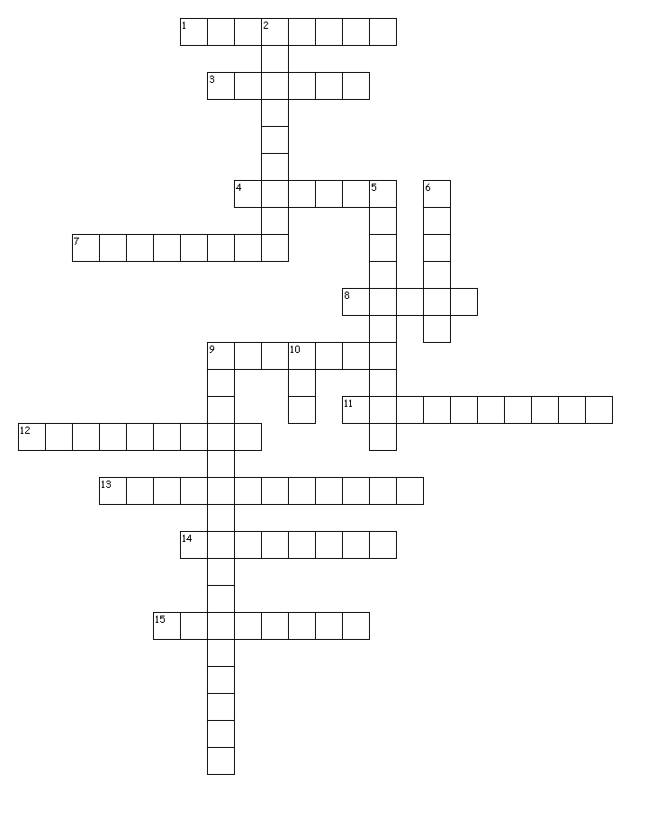

Across
1. type that tells the reader that a story is continued from another page
3. the credit line for the author of an article
4. a vertical section of text
7. large type running above or beside a story to summarize its content; also called a head, for short
8. the practice of placing an image or color so that it extends to the edge of the page
9. ready-made pieces of printed or computerized graphic art
11. the area on a sheet of stationery where the name, address and other information is printed
12. the section on a newsletter that contains the publication name, date, volume number and logo; generally located at the top of the opening page
13. a small publication (3 1/2 x 2 inches) containing information such as name, title, business, address, etc.
14. often located on the first inside page or the editorial page of a publication; contains information such as publisher, staff and contact information
15. a booklet or pamphlet that contains descriptive information or advertising
Down
2. a small amount of text taken from an article that is enlarged and often set off with rules, white space and quotation marks
5. a printed report or letter containing news of interest to a particular group
6. the interior space between margins of two facing pages; sometimes used to describe the space between columns
9. restates the original headline to simplify the process of finding an article that has been continued from a previous page
10. an extension for Adobe Acrobat reader files (Portable Document Format)
16 of 16 words were placed into the puzzle.
Created by Puzzlemaker at DiscoveryEducation.com

Bleed, Brochure, Business card, Byline, Clip art, Column, Continuation line, Gutter, Headline, Jumpline, Letterhead, Masthead, Nameplate, Newsletter, PDF, Pull quote

