Digital Communications I

Unit 4 Typography (2)
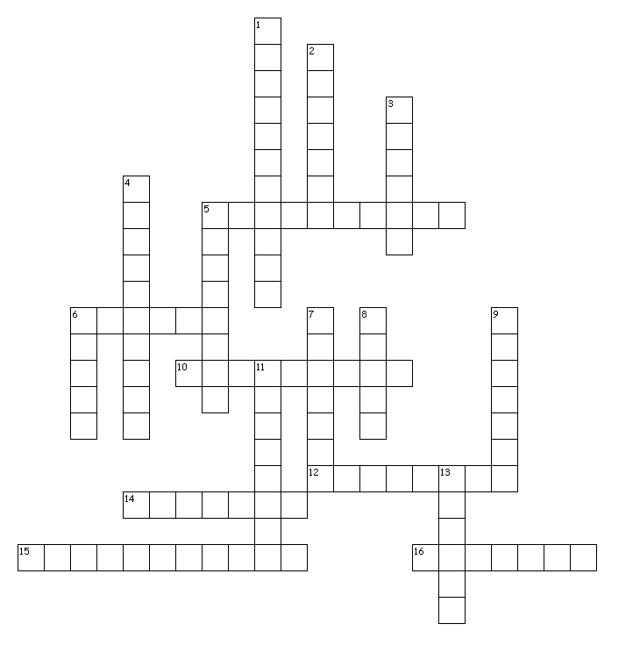

Across
5. the study of all elements of type as a means of visual communication; includes the shape, size, and spacing of characters
6. a formatting style that adds depth to text or other objects, asking them appear more three-dimensional
10. typeface without serifs
12. adjusting the spacing between words, phrases, and extended blocks of text
14. printed in or using characters that slope to the right
15. special formatting style that uses light color text on a dark background
16. a special formatting style creates the illusion of actual textures such as wood, metal, objects in nature, etc.
Down
1. a very short line of text (single sentence or phrase) that appears alone at the end or beginning of a paragraph or column
2. the adjustment of space between pairs of letters to improve its appearance or alter its fit
3. formal or informal typefaces designed to imitate handwriting
4. an enlarged letter that is used as the first character of a paragraph; may be dropped or raised
5. a technique that allows text to flow around a graphic image
6. typeface with projections extending off the main strokes of a character
7. the height of lowercase letters, specifically the lower case, not including ascenders and descenders
8. a unit of measurement used ton describe the size of text; one point=1/72 of an inch
9. the space between lines of text
11. smaller uppercase letters that are about the same height as lowercase letters
13. a feature that sets a temporary left, right, or left and right margin for paragraph text
18 of 18 words were placed into the puzzle.
Created by Puzzlemaker at DiscoveryEducation.com
Indent, Initial cap, Italics, Kerning, Leading, Point, Reverse type, Sans serif, Script, Serif, Shadow, Small cap, Text wrap, Texture, Tracking, Typography, Widow/orphan, x-height,

