Digital Communications I Unit 3 Layout & Design
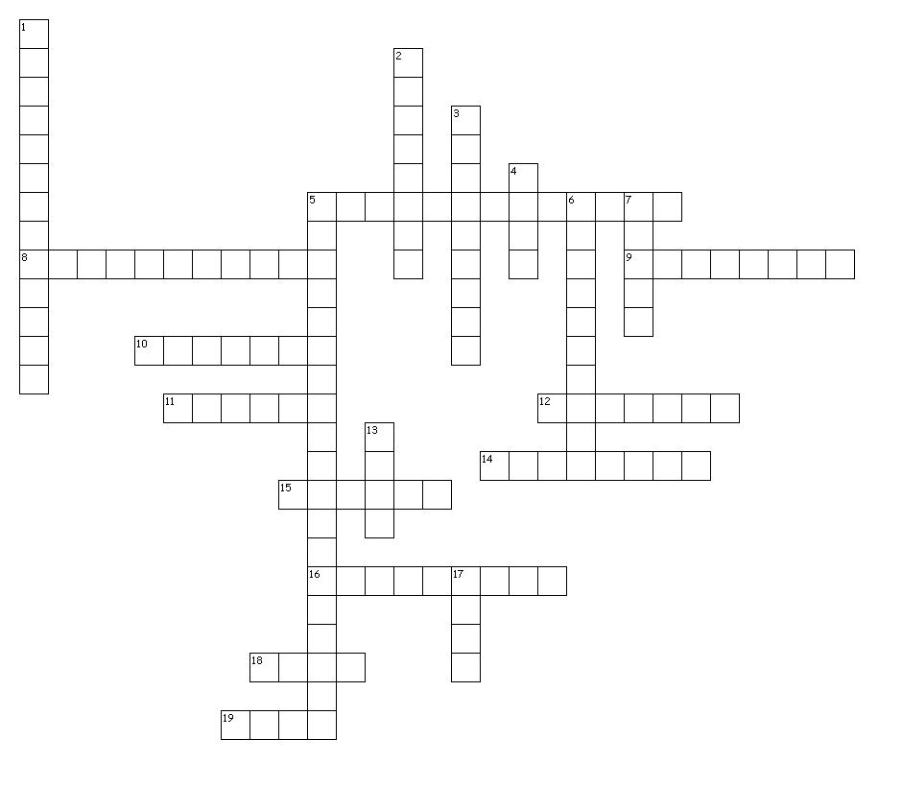

Across
5. a zig zag fold with at least two parallel folds that go in opposite directions; also known as zig-zag
8. maintaining the same layout and style throughout the publication; i.e. fonts, colors, spacing, graphic elements, etc.
9. folding the sides in toward the middle of a page
10. use of elements so they counter each other; creates a product that is in harmony
11. a standard American paper size that is 8.5 x 11 inches
12. the joining of pages with either wire, glue or other means
14. the differences in values, colors, textures, shapes, and other elements within a presentation
15. the arrangement of all key parts of a publication without including specific content.
16. the placement of text or graphics on a line (right, left, center, or justified)
18. standard type of paper used in copiers and printers
19. as a design element, lines can be used to divide or unite elements on a page, denote direction of movement
Down
1. a color that becomes white when all colors have been added; RGB is an example
2. dividing the page in half; often called a booklet fold
3. a heavy weight paper; typically used for business cards, greeting cards, post cards, etc.
4. layout – rough draft of the finished publication that shows the major elements of the publication
5. the type of balance when both sides of the central axis are not identical, yet appear to have
6. the visually dominant elements in a presentation; the center of interest
7. a standard American paper size that is 8.5 x 14 inches
13. the visual path created by the arrangements of elements.
17. the physical or visual size of a publication or an object in the publication.
20 of 20 words were placed into the puzzle.
Created by Puzzlemaker at DiscoveryEducation.com

Accordion fold, Additive color, Alignment, Asymmetrical balance, Balance, Binding, Bond, Card stock, Consistency, Contrast, Flow, Focal point, Gatefold, Half fold, Layout, Legal, Letter, Line, Mass, Mock layout

