Creating an Abstract Watercolor Wallpaper
There are plenty of ways to create a Watercolor Effect in Photoshop. Some are very cheesy and you can easily tell that a simple filter has been used. In this tutorial, we will be using Layer Masking. It is one of the most fascinating and powerful Photoshop method, to use layer masks in your designs.
Preview of Final Image
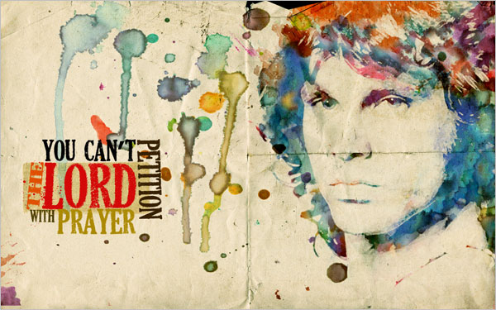
Let us start off by creating opening a black and white image….a picture of Jim Morrison (you can use any of your favorite characters, or your own picture for that matter).

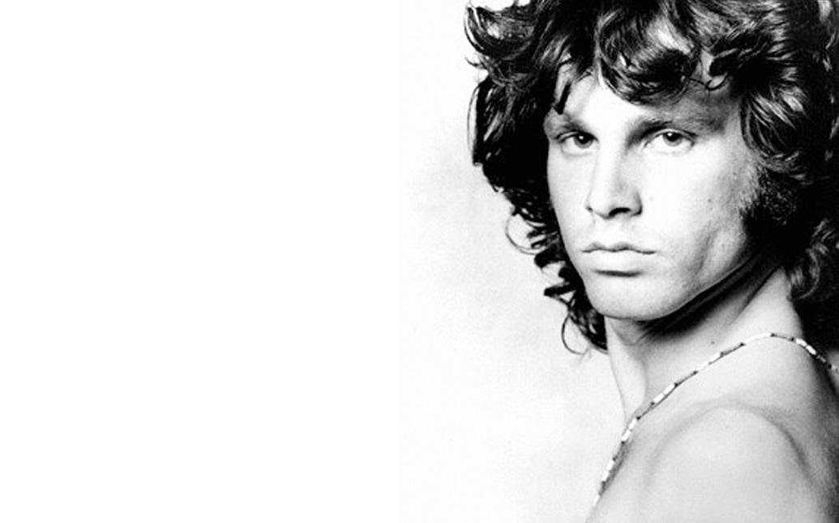

Adjust Brightness/Contrast to make the darks darker and the lights ligher.
Then duplicate the layer and name it “Watercolor Filter”.
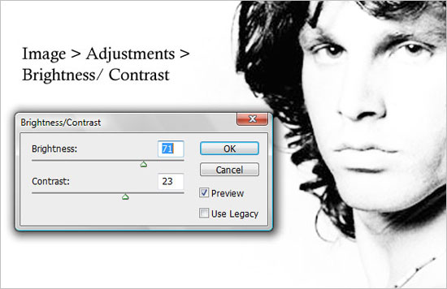
Apply Watercolor filter from filter gallery to the “Watercolor Filter”.
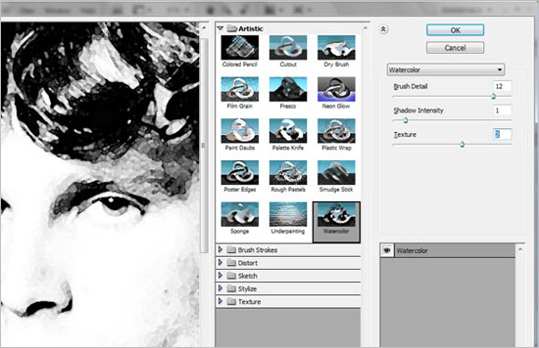
Select the original layer and NOT the “Watercolor Filter”. Go to Image > Adjustments > Threshold. Change the threshold to 152. Rename this original layer “Threshold Effect” by double clicking to unlock and name.
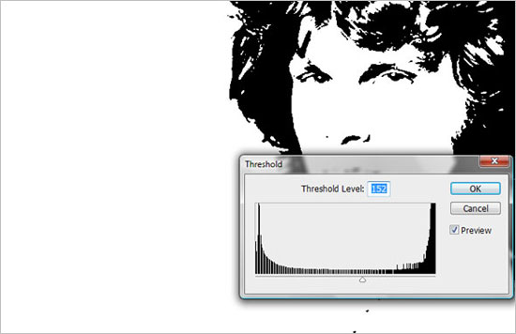
Click on the top layer and set the Blending mode to Multiply, and merge both, “Watercolor Filter” and “Threshold Effect” layers. So, we now have a “Merged Layer”.

Rename the layer “Merged Layer”.
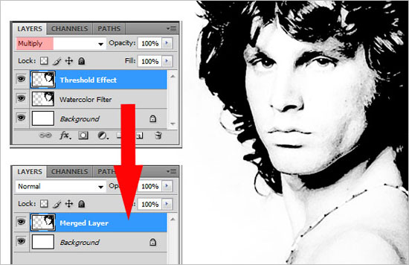

Now place a watercolor image and position it as the top layer because it will be used as fill color on our mask. Basically you will have a new layer above the other layers. Use clone tool to make more color if needed.
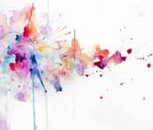
Go to the “Merged Layer” and “Ctrl +A” to select all of the image. Then Edit, Copy.
Click on the Watercolor layer and add a mask. Alt + click on the layer mask, and you will see the canvas is in white.
Paste the image here (Edit/Paste).
Click on the mask and select the entire canvas using a selection tool if not already selected
Ctrl + I on the mask to invert the colors. This way, the layer mask hides the Blacks, and reveals the Whites.
Click back onto the “Merged Layer” and we can see our image. (See below)
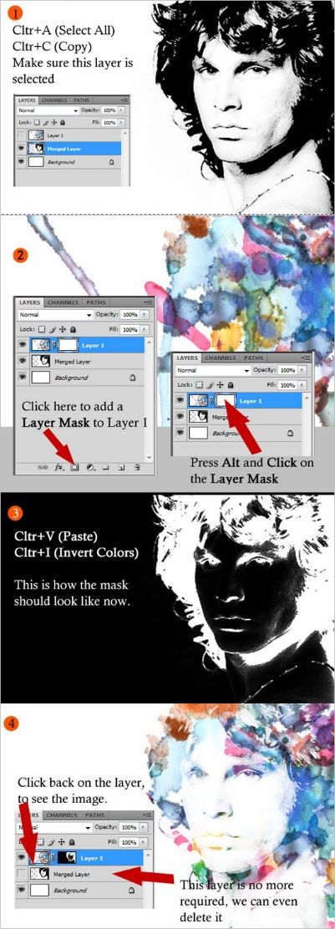

File place the Linen paper image and adjust to be the size of the full canvas. This creates a new top layer named “linen”.
Set the layer to Linear Burn mode.
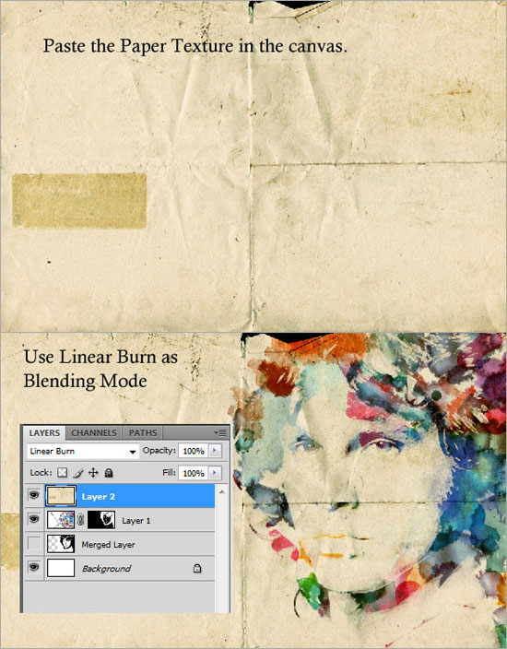
Finally, add some more watercolor splashes from the Media Militia Sample and add a fancy text, oriented like what I have in this image below. Now you have an abstract watercolor design. You can use your creativity and innovate more on this effect. Hope you had fun in this tutorial!

