Color Scheme Activity: Poster Design

Create a tabloid poster to display the classroom expectations listed at the bottom of the page. The thumbnail sketches are examples. The poster should include:

- An approved color scheme. Determine the color scheme that you want to use and get it approved. Any graphic images used must coordinate with that scheme. Clip art is allowed but NO PHOTOS. You can copy/paste clipart from PowerPoint.
- Good balance and design techniques.
- Appropriate fonts.
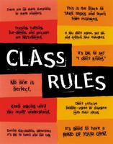
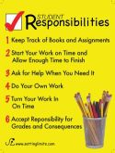
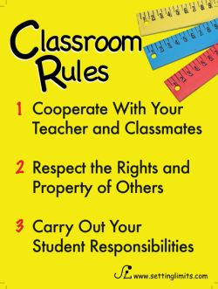
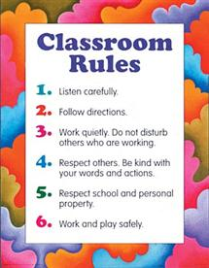

Expectations

- Arrive on time
- Show respect to all
- Work responsibly
- Listen carefully and follow directions
- Refrain from inappropriate language
- Abstain from eating and drinking
- Keep hands, feet, and all other objects to yourself

