Warhol Style Pop Art Using Photoshop

Choose an image where it's been photographed against a plain background. This one is with the backdrop of a clear blue sky but any plain background will work.

Step 1: Select the dandelion
Go to Select>Color range and in the dialogue box that pops up tick the Invert box. Then click on the background area of either the photo or the image in the dialogue box and adjust the fussiness slider. We are adjusting it so that the sky shows through the dandelion head, so you can see the individual seed stems. Click ok. The box will close and the photo will have a complex set of "marching ant" selections all over the head.
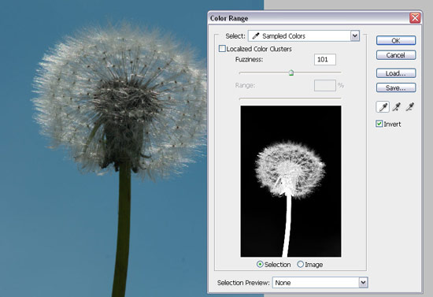

Step 2: Paste the subject onto a new layer
Copy (ctrl+C) and then paste (ctrl+V) to paste a selection onto a new layer which will now be active. If the layers palette isn't showing go to the menu Windows > Payers, or press the F7 key (once to open, once to close).
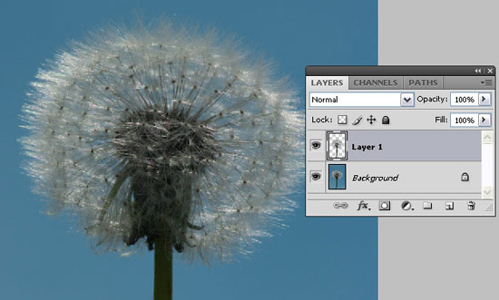

Step 3: Adjust the threshold
Go to Image > Adjustments > Threshold and slide the white triangular marker under the histogram (graph) towards the left. So, with our image, this means that the head is mostly white and the stalk black, leaving just a few black seed tips as specs in the head.
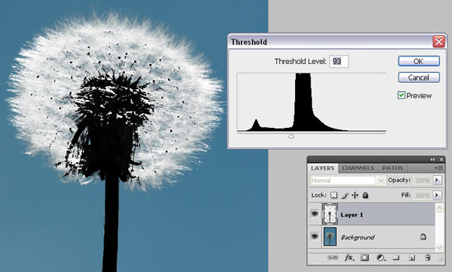

Step 4: Select the stalk
With the new layer still active go to Select>Color range again and this time untick the Invert box and click on your subject, in our case we have chosen the dandelion's stem. Now we need to adjust the Fuzziness slider so that just the stem and the centre of the seed head is showing with a few scattered seed head specs. After clicking OK, the box will close and the photo will have the "marching ant" selection all over the stem and inner dark area of the head.

Step 5: Paste on to a new layer
Repeat step 2 by copying (ctrl+C) and then pasting (ctrl+V) to paste the copied selection on a new layer which will now be active.

Step 6: Fill the background colour
Click on the background layer and go to Edit > Fill . Select Color from Contents Use drop down. Choose a bright colour for the background from the pop up window ( I set mine to be blue) and click OK. You'll see the photo is now starting to take shape.
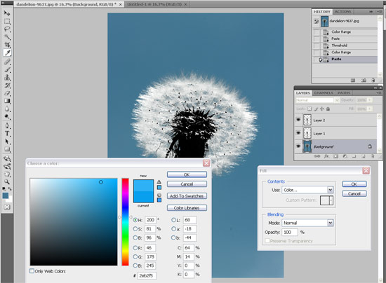

Step 7: Change the colour of the dandelion head
Now for the fun colour stuff. Click on layer 1 to make it active and go to Image >Adjustments > Hue >Saturation. Tick the Colorize box and Drag the saturation slider across to the right and the lightness slightly to the left to produce a really bright colour. The colour you now create is controlled by the Hue slider. In this example, I've set it to yellow.
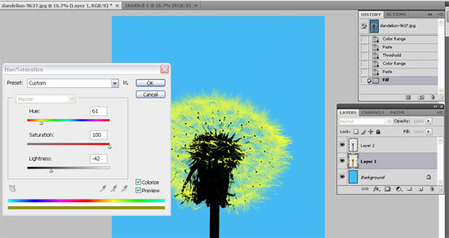

Step 8: Color the stalk
Repeat step 7, but on layer 2. This time you will need to set the lightness to lighter by dragging the slider to the right and saturation wants increasing again. Experiment with each slider until you get a contrasting Pop Art style color.
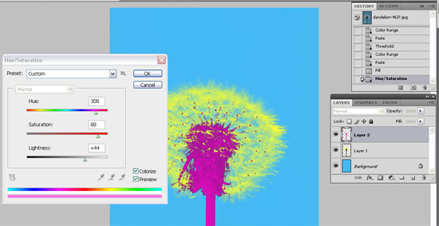

Step 9: Save photo as a .psd file
Save the photo as a PSD file and all the three layers will be saved. Now you can come back and create different colors for each layer using the above steps. When you're happy with a colour scheme save your picture using File > Save As so the original PSD is preserved.
Try to combine four photos - each with different color schemes on a larger canvas to be really like the Warhol style.
