Name__________________Class_____Date______

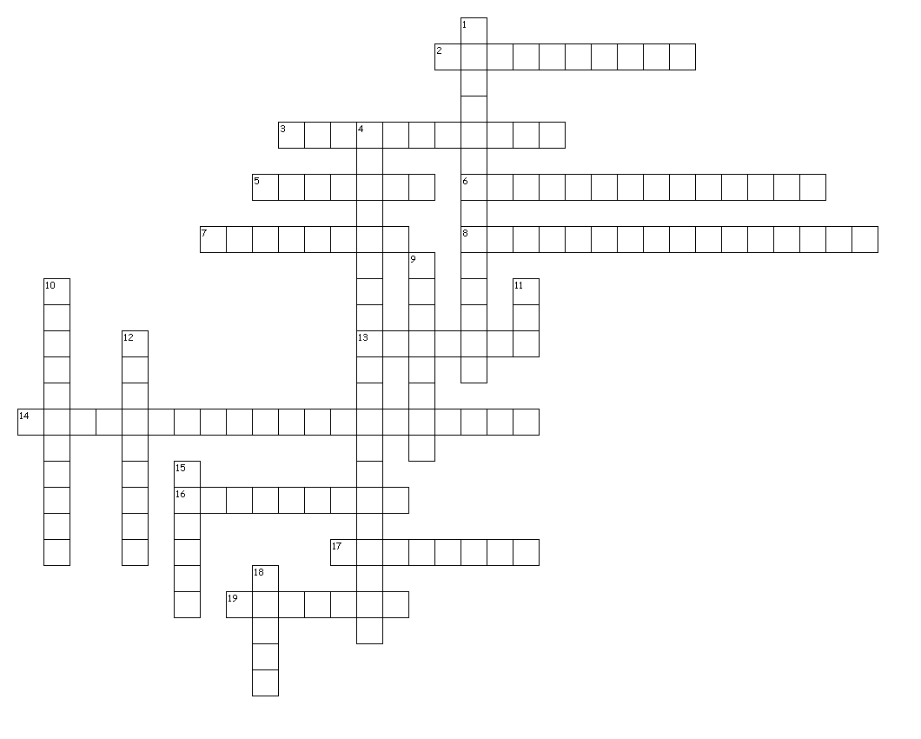
Digital Communications II - Unit 1
Word bank
Bluetooth
Burner
Cloud computing
Compact disk
Digital Video Disk
Drawing software
Flash drive
Flash memory
Gigabyte
Image editing software
Kiosk
Megabyte
Optical storage
Painting software
Point and shoot cameras
Scanner
SLR
Terabyte
Universal Serial Bus port
Across
2. a plug-and-play portable storage device that uses flash memory and is lightweight enough to attach to a key chain; also known as a pen drive, keychain drive, thumb drive, jump drive
3. an optical storage medium made of molded polymer for electronically recording, storing, and playing back audio, video, text, and other information in digital form; also CD-ROM, CD-R, CD-RW
5. software program used to create vector graphics; provides for freehand as well as geometric shapes
6. storage device that records data by burning microscopic holes in the surface if the disk with a laser
7. a unit of storage measuring roughly one billion bytes
8. programs used to create bitmap images; useful in creating original art because they provide the tools used by artists (such as brushes and pens)
13. an input device that converts hard copy, such as photos and documents, to a digital copy
14. software designed to edit, manipulate or modify digital photographs
16. Serial Bus port a connection port used to connect various outside devices, i.e. flash drives, USB cables
17. a unit of storage measuring roughly one trillion bytes
19. Video Disk an optical disk with a capacity of 47 Gb or more that can hold a full-length commercial movie; also DVD-ROM, DVD-D+\-R, DVD+\-RW, Blu ray
Down
1. use of web services to perform functions that were traditionally performed with software on an individual computer, i.e. Flicker, Picasa, Google Docs, Picnik)
4. a still camera used for simple operations
9. a unit of storage measuring roughly one million bytes
10. sometimes called "flash ram"; is solid-state memory that can be erased and reprogrammed; gets its name because the microchip is organized so that a section of memory cells are erased in a single action or "flash"
11. camera that has a detachable lens
12. wireless technology to transfer data
15. a CD or DVD writer; can be internal or external
18. a free-standing electronic system that allows transactions or provides information, such as DVD Rental, ATM, gift registry, photo development, etc.
19 of 19 words were placed into the puzzle.
Created by Puzzlemaker at DiscoveryEducation.com

